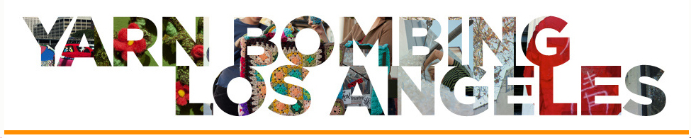
For Immediate Release

Contact:
Yarn Bombing Los Angeles

yarnbombing18@gmail.com

www.yarnbombinglosangeles.com

Tel. 310-560-5004

YARN BOMBING LOS ANGELES TO COVER THE CRAFT AND FOLK ART MUSEUM IN GRANNY SQUARES May 25th, 2013

Yarn Bombing Los Angeles (YBLA) will cover the facade of the Craft and Folk Art Museum (CAFAM) at 5814 Wilshire Blvd. Los Angeles, CA in crocheted granny squares for a public art display that will unveil on May 25th, 2013 @ 5pm.

CAFAM Granny Squared is a ground breaking, temporary public art installation on the Museum Row in Los Angeles, CA. This is a community-based project that anyone can contribute to, and anyone walking on the street can enjoy. The project is designed to bring together a community of artists and crafters who otherwise might not have had access to exhibit their work in a museum. So far over 500 crafters from 50 states and 25 countries joined to crochet 12,000 5inch granny squares. YBLA hosts community meetings at CAFAM every 3rd Saturday, 3-5pm, that everyone interested in the project is invited to join in on sewing the grannies together and preparing for the event. For images please visit https://www.dropbox.com/sh/fvecgmftcr7577d/Z1wwPVfLCt?n=7954227

On a conceptual level the project aims to question the boundaries between art and craft, use scale and color to play with artistic, architectural and institutional identities. YBLA suggests a parallel between how the Craft and Folk Art Museum is dwarfed by the grandiose structures and other museums across the street on Museum Row, and how craft is dwarfed by traditional notions of “high art”. To deconstruct this dynamic, YBLA will be covering CAFAM in brightly colored, oversized granny squares and other colossal graphic patterns to visually turn CAFAM into a dollhouse and thus "shrinking" it even more and making a commentary on artistic and institutional identities associated with craft, a lesser art form by manipulating architecture, often regarded the highest art form. After de-installation, the crocheted squares will be sewn into blankets and distributed to the residents of Skid Row.

Yarn Bombing Los Angeles (YBLA) is a group of guerrilla knitters who have been collaborating since 2010 to stage public installations and performances to help expand the definition of public art to include self-initiated and temporal urban interventions such as yarn bombing. For more info visit www.yarnbombinglosangeles.com

Yarn Bombing Los Angeles 1653 18th St. #5 Santa Monica, CA 90404 yarnbombing18@gmail.com 310-560-5004
w w w .y a r n b o m b I n g l o s a n g e l e s. c o m

